Comparative Analysis of Machine Learning Models for Detecting Image Steganography using Noise-Based Features
Appalla Sai Shivanand
SRM University AP
Department of CSE (AIML)
MTech Integrated CSE (AIML) - 1st Year
asaishivanand@gmail.com

Abstract
This study investigates the effectiveness of different machine learning algorithms in identifying hidden information within digital images. A controlled experimental setup was designed using synthetically generated datasets and noise-based steganographic techniques. Feature extraction methods including statistical, edge-based, and texture-based features were utilized. Logistic Regression, Random Forest, and Support Vector Machine (SVM) were evaluated, achieving accuracies of approximately 81–83%.

Keywords
Image Steganography, Machine Learning, Steganalysis, SVM, Random Forest

1. Introduction
With the increasing use of digital communication, secure data transmission has become essential. Image steganography enables hidden communication within images, making detection challenging. Machine learning techniques provide efficient ways to detect hidden patterns and improve steganalysis.

2. Literature Review
Previous studies have explored statistical and machine learning techniques for steganalysis. Early work focused on detecting pixel anomalies, while recent approaches utilize machine learning and deep learning models. This study focuses on lightweight models for efficiency and interpretability.

3. Methodology
The proposed framework involves data generation, feature extraction, and model evaluation. A synthetic dataset was created using geometric patterns. Controlled noise was introduced to simulate steganographic embedding. Features such as mean, standard deviation, edge detection, and texture variations were extracted. Models were trained and evaluated using stratified sampling. All experiments were conducted using Google Colab.

4. Results and Discussion
Logistic Regression and SVM achieved an accuracy of 83.33%, while Random Forest achieved 81.67%. The results demonstrate that lightweight models can effectively detect hidden data under realistic conditions.
Fig. 1: Accuracy Comparison of Machine Learning Models
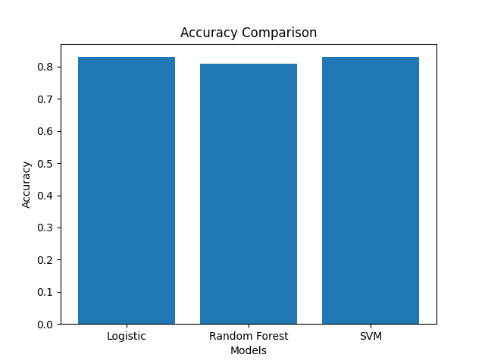

5. Conclusion
The experimental findings confirm that machine learning models can effectively detect hidden data within images. Future work can explore deep learning approaches and larger datasets.

6. References
[1] Johnson & Jajodia (1998)
[2] Fridrich (2009)
[3] Goodfellow (2016)

